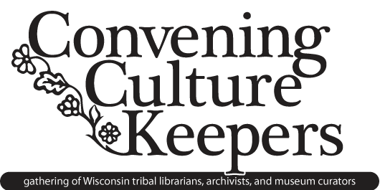**CONVENING CULTURE KEEPERS:**

**ESTABLISHING REGIONAL NETWORKS**

**Omar Poler, Dawn Wing, Robin Amado**

**Wisconsin’s Network Timeline**

**2007** Red Cliff Library faces closure; tribe and local library system reaches out to SLIS for professional support.

**2008** SLIS students receive grant to begin service-learning project to assess Red Cliff’s information needs and determine the community’s own vision for a new facility.

**2009** Student interest in Red Cliff and other existing tribal institutions leads to the creation of the TLAM course, with support of LIS program. The class is largely student-driven, with a focus on experiences outside of the classroom in the tribal communities.

**2010** Convening Culture Keepers is co-created by SLIS Continuing Education Services and tribal partners to address the need for relevant and meaningful professional development and networking.

**2011** TLAM Student Group is created to extend support of projects year-round and to continue to foster important relationships**.**

**2012** Red Cliff and SLIS partner with consultants, architects, and non-profits to begin the capital campaign for the Red Cliff community facility, *Ginanda Gikendaamin*.

TLAM celebrates four years of building relationships and service-learning experiences.

**You can find more information about our Network, including the Convening Culture Keepers mini conferences, the TLAM course, and our service-learning partnerships by visiting our website at** [**www.tlamproject.org**](http://www.tlamproject.org)**.**

**CONVENING CULTURE KEEPERS:**

**ESTABLISHING REGIONAL NETWORKS**

**Omar Poler, Dawn Wing, Robin Amado**

**Suggestions for Beginning Your Own Network**

*Identify needs in your own space.*

*Reach out to existing networks or to a new contact.* Find resources through AILA, ATALM, or contact faculty in a LIS program (see a map by visiting <http://goo.gl/maps/1ICQ>) or American Indian Studies program.

*Spend time together.* Recognize that visiting face-to-face has special personal meaning.

*Have meals together.*

*Establish an institutional home*. Identify a foundation for consistency and stability.

*Understand (and find) the resources to share*.

*Acknowledge that everyone has different skills and different needs.*

*Involve the community.*

*Let curiosity drive learning.* Encourage dialogue in-class about relevant community engagement topics

(ie: Indian boarding schools, language preservation, Indigenous cataloging). Assign journal or blog entries on personal investment and meaning of service learning projects

*Be a teacher and a student.*

Think politically; advocate for yourself within your institutions

*Maintain consistent, ongoing communication to clarify types or changes in service.*

*Remember to be patient*. Projects take years to develop, relationships take time to strengthen

Remember process is as important as outcome; it’s about friendships.